# Homework: Databases

Problems for homework for the ["Software Technologies" course @ Software University.](https://softuni.bg/trainings/4086/software-technologies-may-2023)  
Submit this document as your homework.

## Address Database:

1. **CREATE DATABASE** named `**address_database**` and USE it:

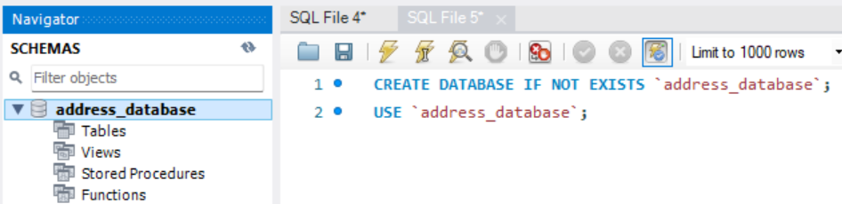

1. **CREATE TABLE** named `**addresses**` with the following columns:
   * **street_number**
   * **street_name**
   * **area**
   * **town**
   * **district**
   * **country**
   * **continent**

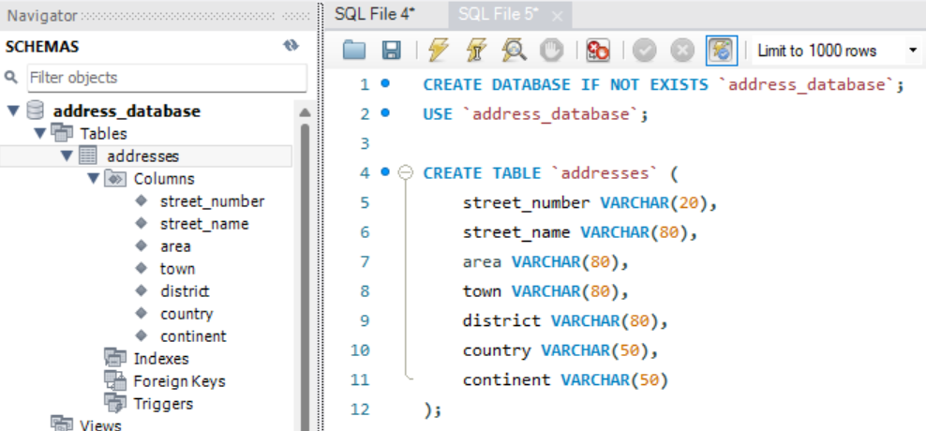

1. We forgot to **add Boolean column**, named `**isCapital**`:

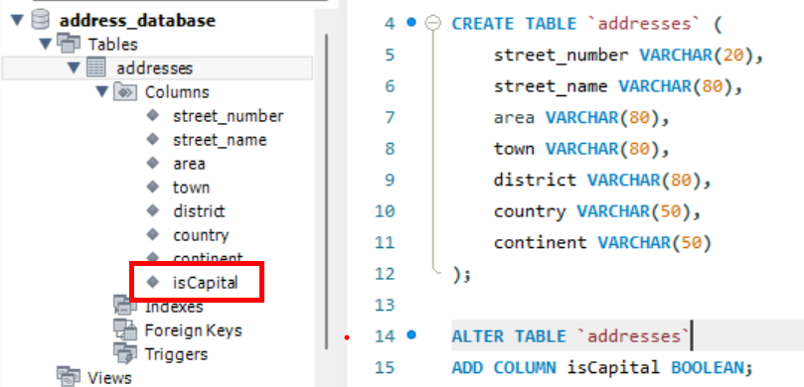

1. **INSERT** records **INTO** the `**address**` table and execute the SQL query:

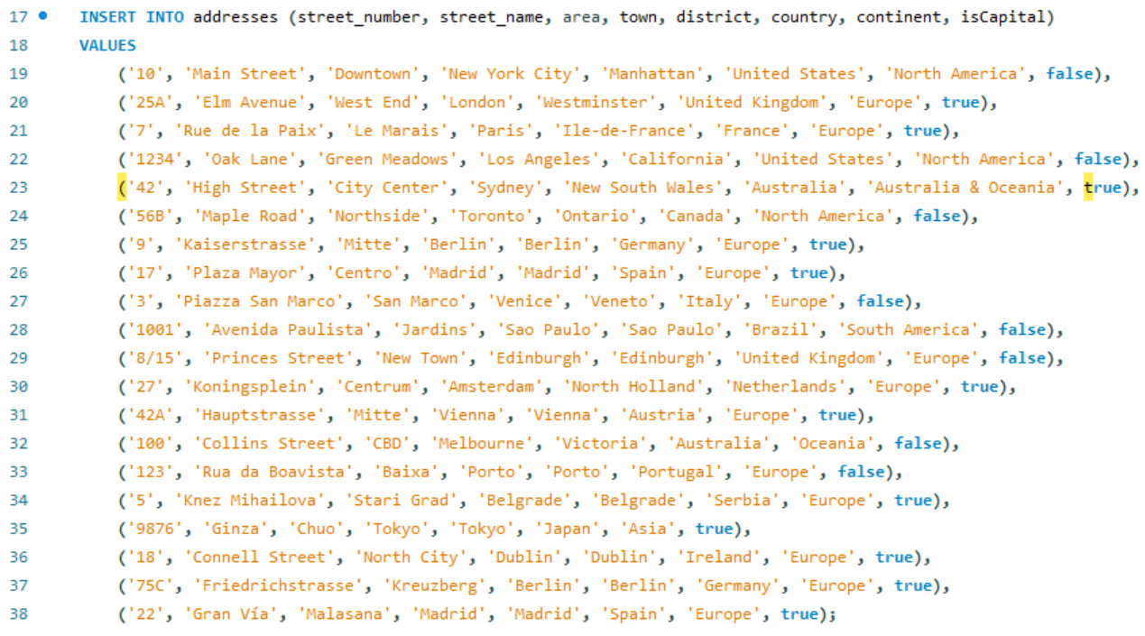

1. **Your task is to execute the proper queries in order to get the following results:**
   * **SELECT all addresses from the `address` table that are located in a capital city.**
   * **SELECT all addresses from the `address` table that are located in South America.**
   * **SELECT all addresses from the `address` table that are located in Europe, but only in NON Capital cities.**

* **Create queries for each condition and place a screenshot after each query !**

1. **SELECT all addresses from the `address` table that are located in a capital city.**

SELECT * FROM addresses WHERE isCapital = TRUE;

|  |  |  |  |  |  |  |  |
| --- | --- | --- | --- | --- | --- | --- | --- |
| 25A | Elm Avenue | West End | London | Westminster | United Kingdom | Europe | 1 |
| 7 | Rue de la Paix | Le Marais | Paris | Ile-de-France | France | Europe | 1 |
| 42 | High Street | City Center | Sydney | New South Wales | Australia | Australia & Oceania | 1 |
| 9 | Kaiserstrasse | Mitte | Berlin | Berlin | Germany | Europe | 1 |
| 17 | Plaza Mayor | Centro | Madrid | Madrid | Spain | Europe | 1 |
| 27 | Koningsplein | Centrum | Amsterdam | North Holland | Netherlands | Europe | 1 |
| 42A | Hauptstrasse | Mitte | Vienna | Vienna | Austria | Europe | 1 |
| 5 | Knez Mihailova | Stari Grad | Belgrade | Belgrade | Serbia | Europe | 1 |
| 9876 | Ginza | Chuo | Tokyo | Tokyo | Japan | Asia | 1 |
| 18 | Connell Street | North City | Dublin | Dublin | Ireland | Europe | 1 |
| 75C | Friedrichstrasse | Kreuzberg | Berlin | Berlin | Germany | Europe | 1 |
| 22 | Gran Via | Malasana | Madrid | Madrid | Spain | Europe | 1 |

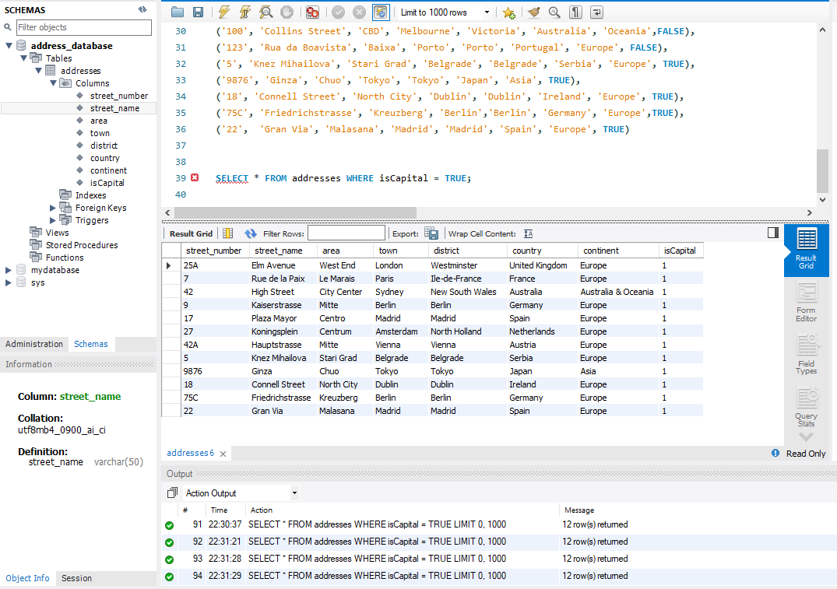

1. **SELECT all addresses from the `address` table that are located in South America.**

SELECT *

FROM addresses

WHERE continent = 'South America';

|  |  |  |  |  |  |  |  |
| --- | --- | --- | --- | --- | --- | --- | --- |
| 1001 | Avenida Paulista | Jardins | Sao Paulo | Sao Paulo | Brazil | South America | 0 |

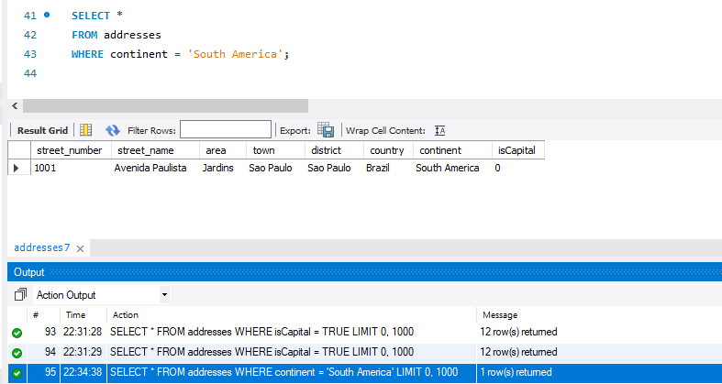

1. **SELECT all addresses from the `address` table that are located in South America.**

SELECT *

FROM addresses

WHERE continent = 'Europe' AND isCapital = FALSE;

|  |  |  |  |  |  |  |  |
| --- | --- | --- | --- | --- | --- | --- | --- |
| 3 | Piazza San Marco | San Marco | Venice | Veneto | Italy | Europe | 0 |
| 8/15 | Princes Street | New Town | Edinburgh | Edinburgh | United Kingdom | Europe | 0 |
| 123 | Rua da Boavista | Baixa | Porto | Porto | Portugal | Europe | 0 |

